# Week 8 Homework:

1. Now that our Bluetooth Speaker is complete, create a drawing for it similar to this:

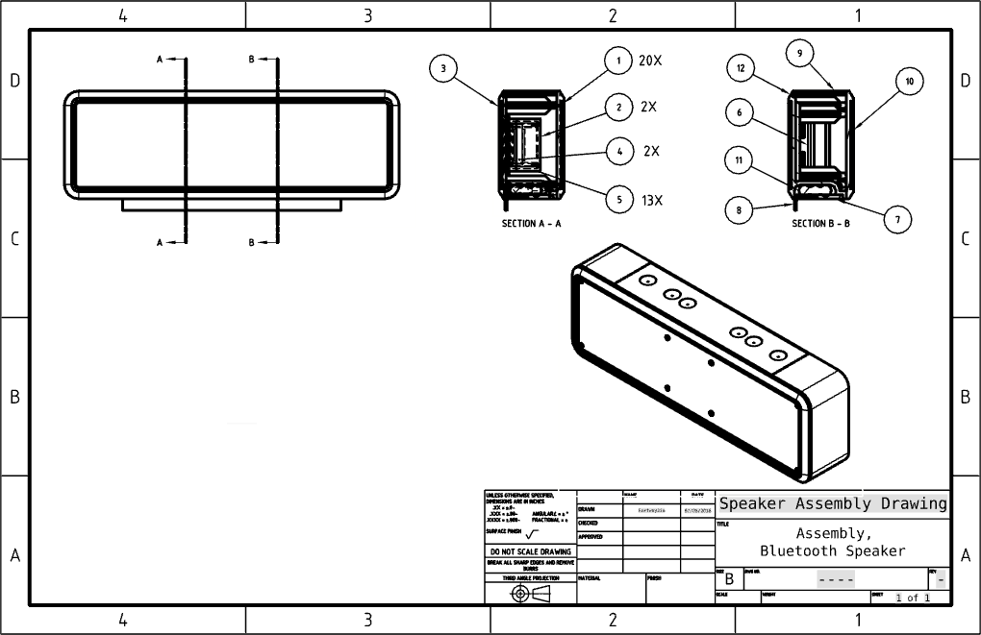

1. Using what we learned in Week 8 about assembling fasteners, add fasteners to your multi-speaker design from Week 7 homework.